**Business Intelligence – decision support**

In this project I had to work with data provided by a real company about their sales. It’s a quite small company with only 10 employees or so and their data management wasn’t exemplary. All their records were stored in excel sheets and not well-organized.

We did really hard-work for one month and the result had shown to the company that they could do way better in terms of data management.

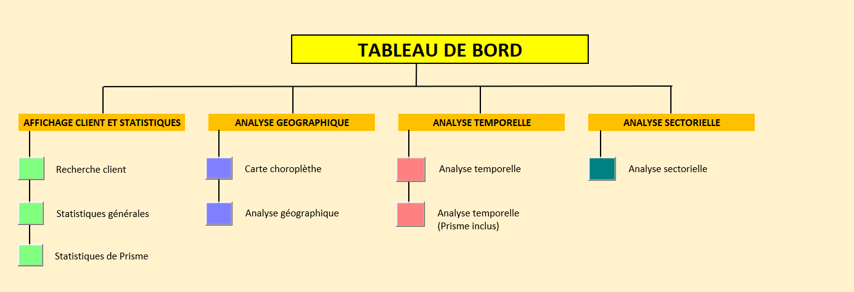

As you can see we splitted the data analysis into 4 main axes: time, space, activity sector and statistics.

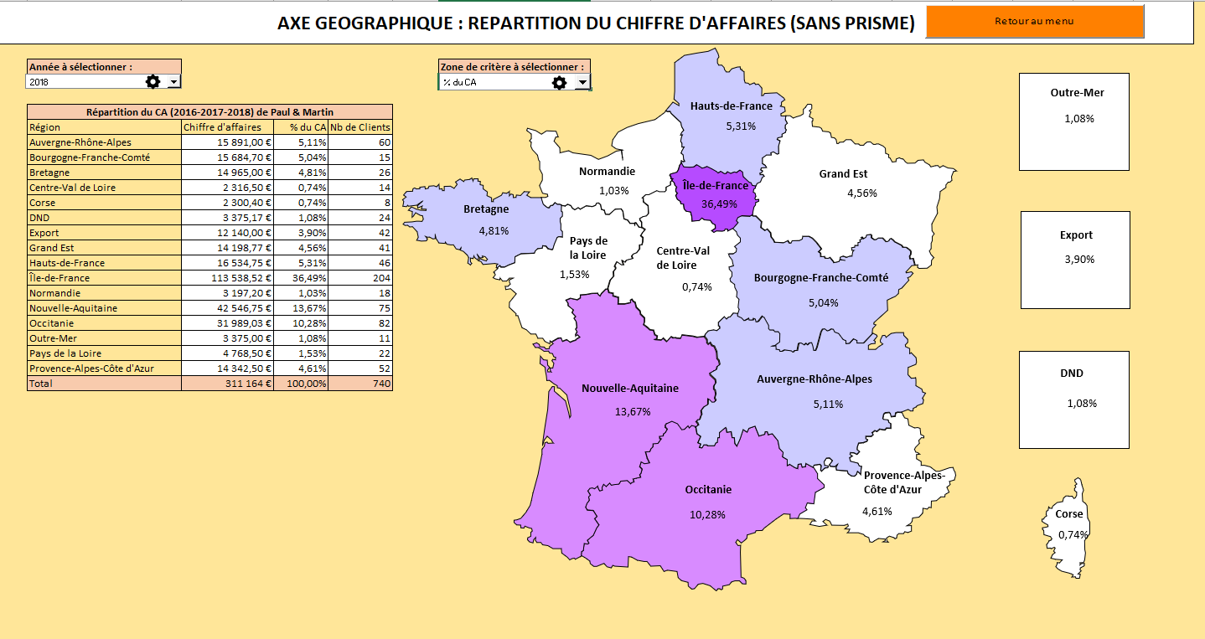

The map was the most challenging part as we have to gather data by regions, define scales, link each shape to a specific region…

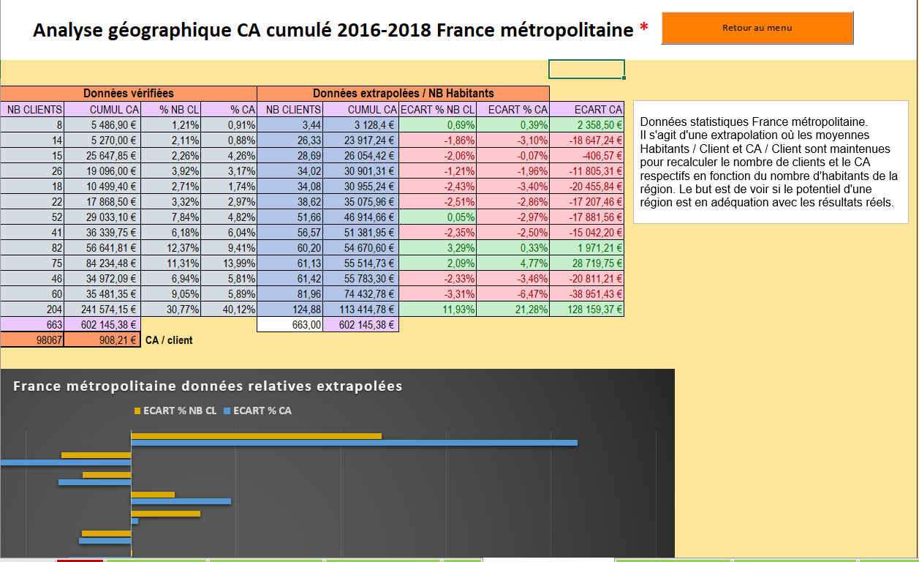

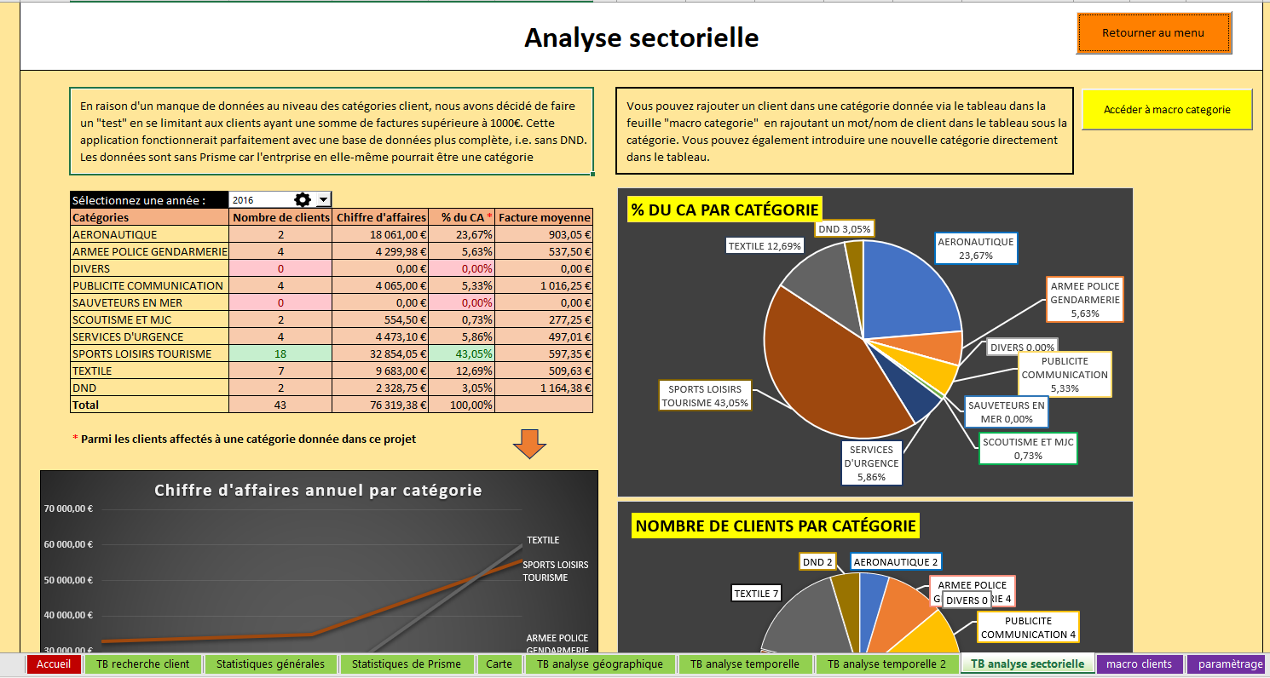

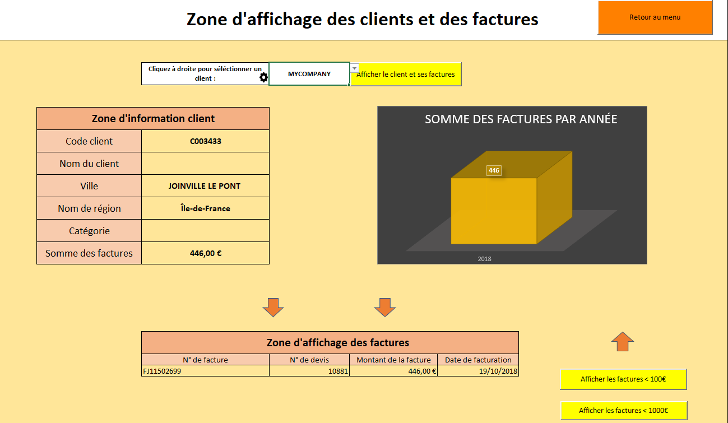

This wasn’t the most exciting project I ever had as I am not a big fan of excel but I found it quite satisfying to see how much a proper data management can simplify the work of a company, even with this simple tool.

**Oporctunite web – disrupt campus**

Oporctunite project was the result of the collaboration of Law, Psychology and Computer science students during the 2019-2020 edition of Disrupt’Campus (see for more information).

Our team had to work on creating an app as a Proof-of-Concept for a Veterinarian School (ENVT). The main idea is to allow sow breeders to evaluate their cattle with a series of tests and that would give them an idea of what could be improved as well as how they compete to other breeders. The app was also designed to veterinarians as they can also create accounts, follow farms and check their results to allow a better follow-up.

Disrupt’Campus Toulouse has also taught us the concepts of Design Thinking and the Art of Pitching.

The website is hosted on https://oporctunite.envt.fr/ (I do not contribute anymore to this project though)

Mockups with adobe.xd (learnt basics of UI/UX)

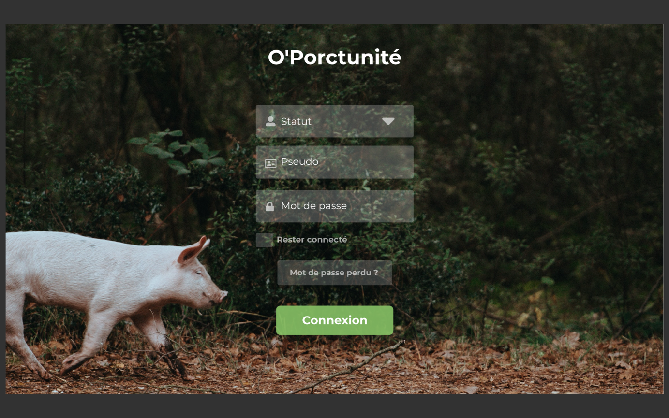

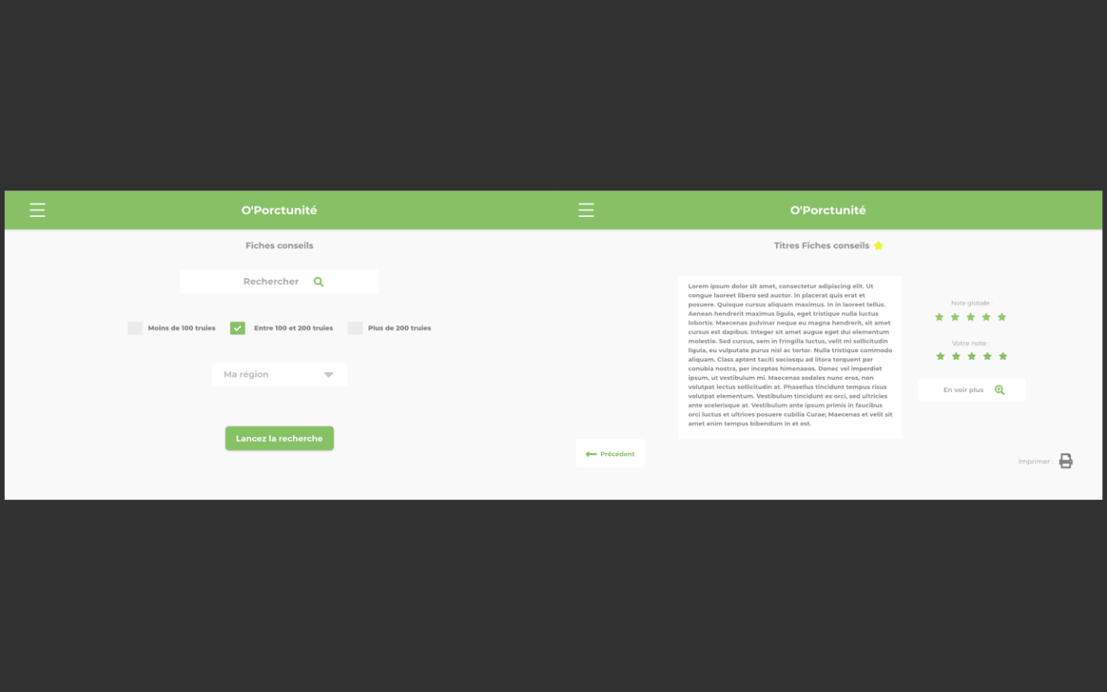

Php CI website – mysql database

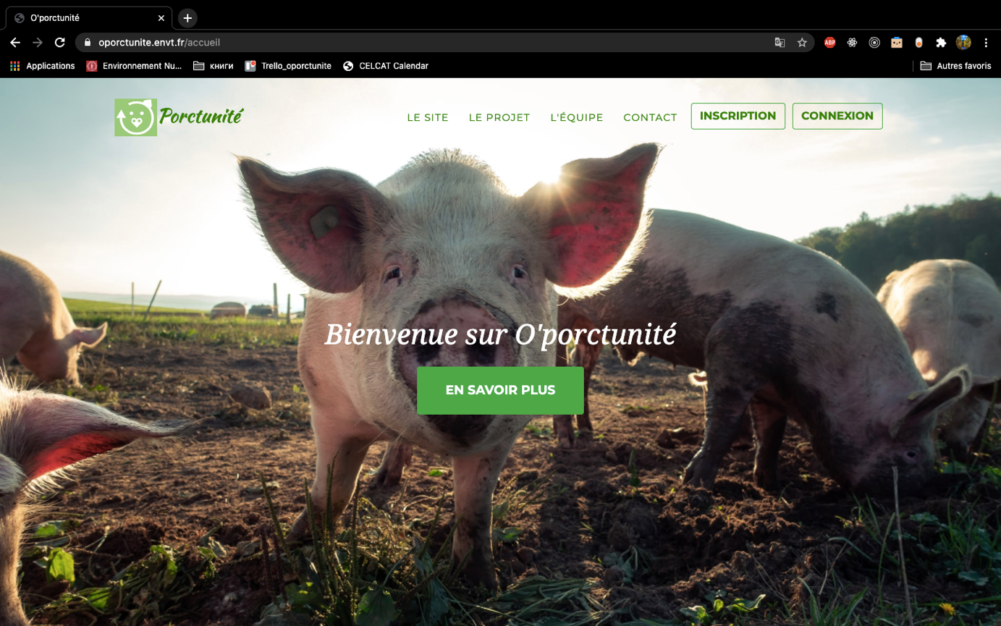

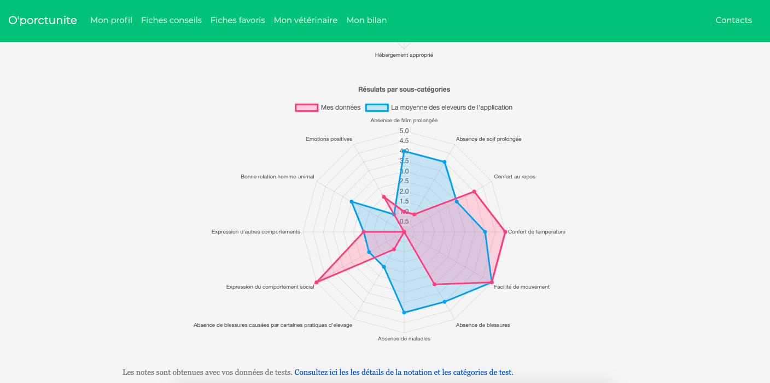

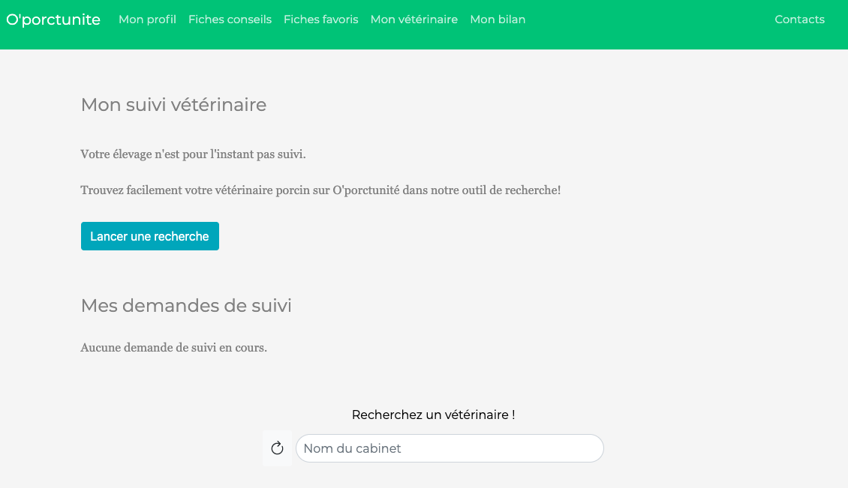

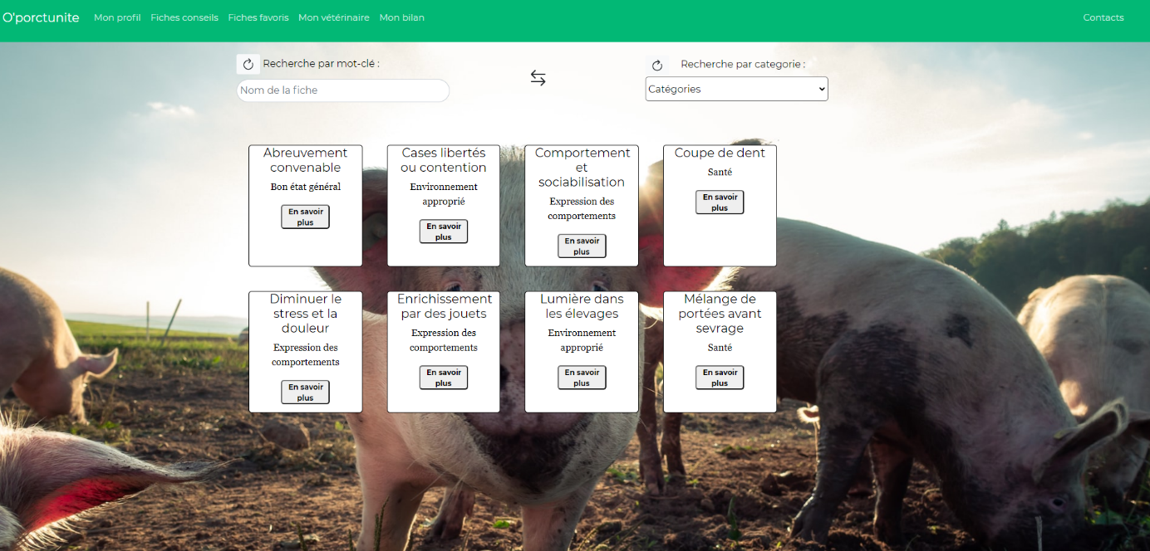

**Oporctunité mobile – stage**

*Mockups image on PC (drawings)

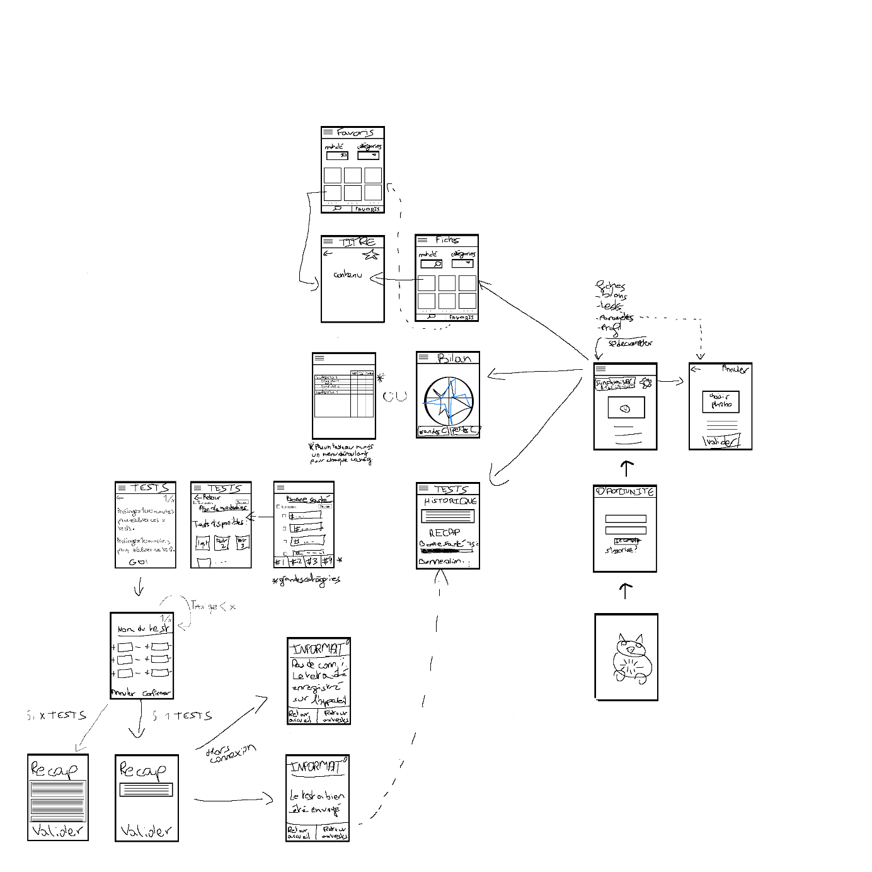

Used postman teams for testing api’s endpoints

Provided extensive documentation and api specification

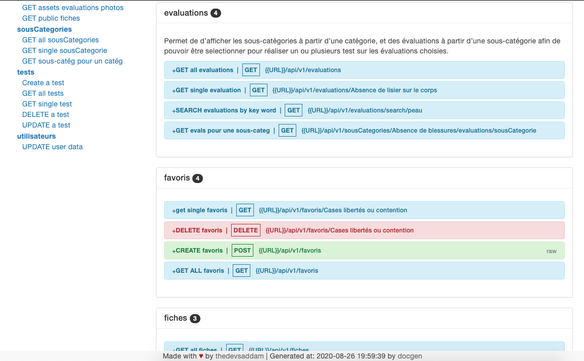

Node.js api, oAuth2 implementation

React native mobile app

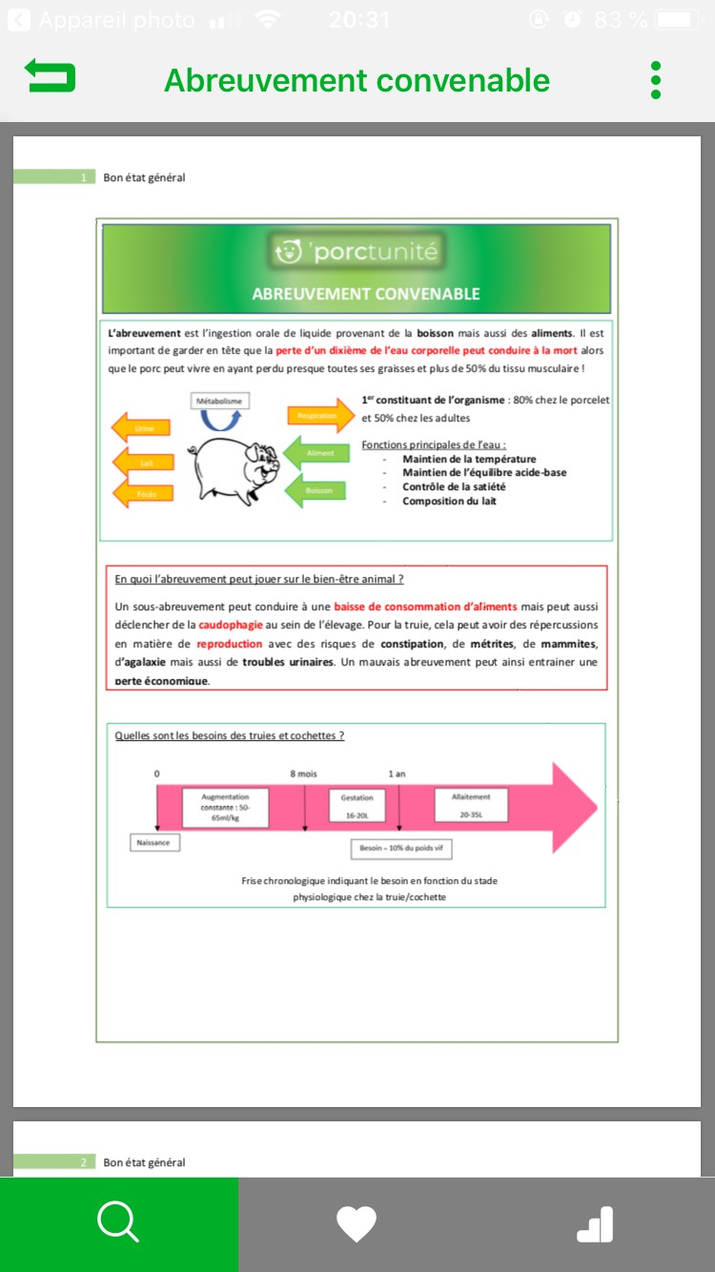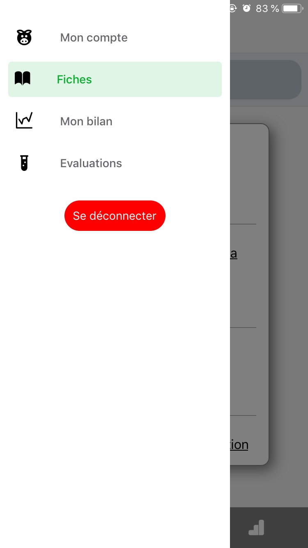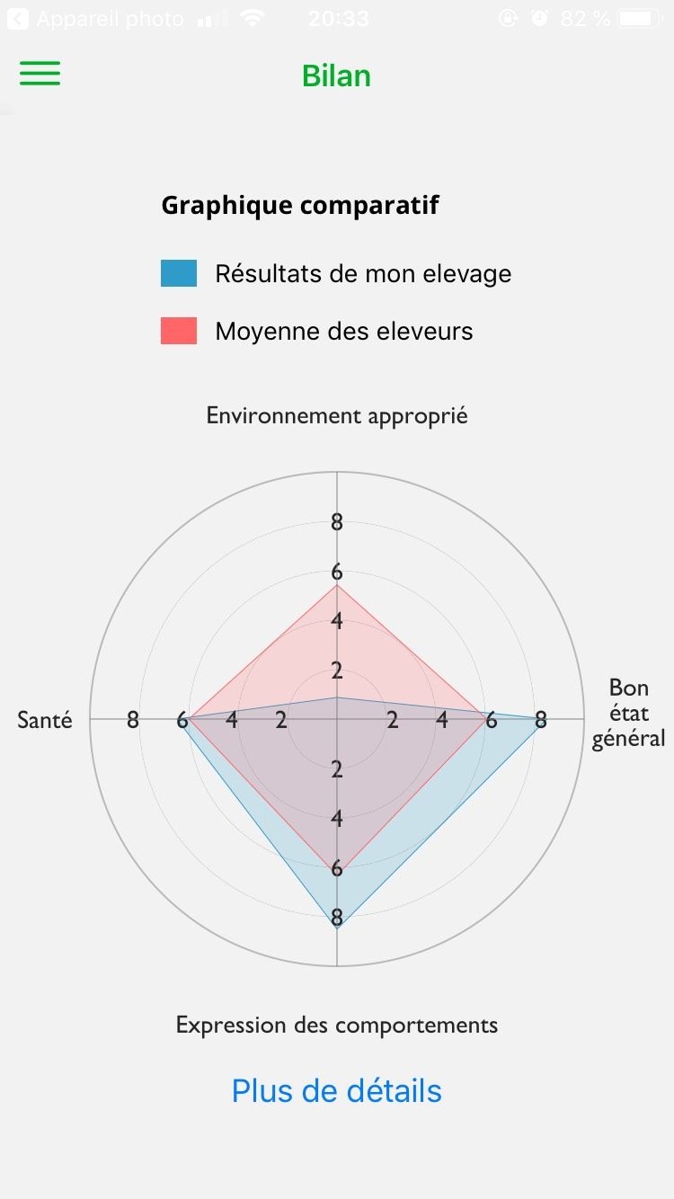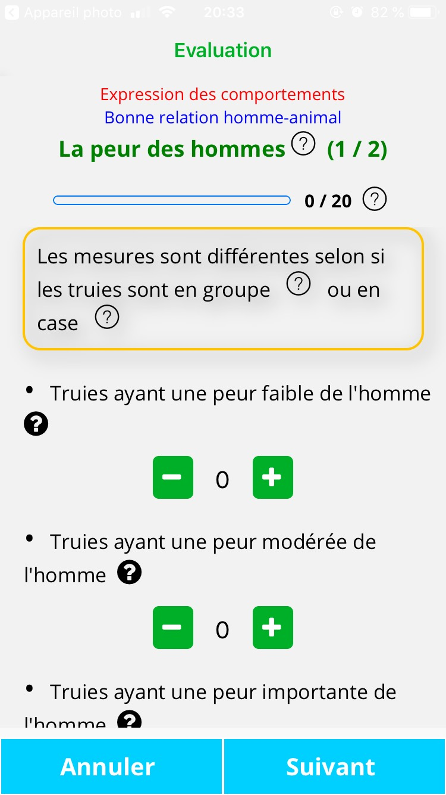

**Twitter twitts retwitts probability with Weka**

Small but very interesting project with using the Twitter developer api to search twitts about a certain topic, using weka to predict retwitts, first ML algo experience. It’s not a very popular software as most people mostly think of python libraries for ML but this software is actually pretty good for learning, testing ML algos on a set of data. It’s mostly used by Academics as it’s maintained by professors from a Uni in NZ…

**Machine learning – Periodontal Diagnosis**

The purpose of this project was to apply different techniques of machine learning on a realworld dataset. The dataset studied contained different features of patients from the Centre Hopitalier Universitaire (CHU) of Toulouse, and had the purpose of defining if the patients were at risk of having a disease on their tooth supporting tissues. The machine learning techniques applied were: SVM, KNN and Random Forest. After preprocessing the data and tuning the models to obtain the best results for the available data, the most accurate algorithm was a linear SVM model, with a 100% accuracy.

These results were very encouraging and we could easily imagine such a model sort of back-checking doctors in their diagnosis or alert them when a diagnosis seems very unusual.

The most challenging part of the project was, as very often in ML projects, the preparation of the data. We had to test different solutions on how to deal with missing data (deleting the whole row, interpolate a value, consider null values as ‘real’ data by transforming them into a category ‘undefined’…)

**Deep learning – Estimate the age of a dead body based on his teeths**

In this project we had data from the same Hospital as in the Periodontal Diagnosis, but this time we had as input data, images (X-rays) from the teeths of 3326 patients. We also had the ages of the patients. We trained a Convolutional neural network on the input data.

Having images instead of text, numbers as input data was very challenging as we had to figure out how to select the important information from the images using Threshold techniques and Masks, but also the images themselves weren’t always of the same dimensions. Then loading 30k+ images to train a network is quite challenging for the processor as well and a train/test cycle was usually taking up to 30min…

At the time of writing this the project is still ongoing so I cannot provide any results yet !

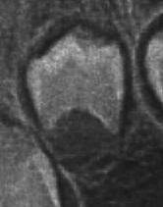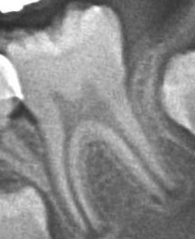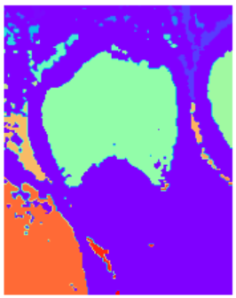

**Go-roots : Smart building – IoT + web**

**(web)**

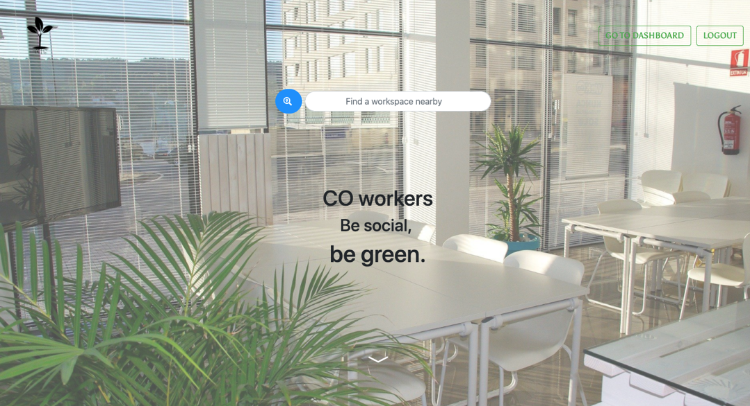

Co-Workers is the result of two weeks of works. We were asked to improve co-working spaces and our decision was to create a social network for co-working spaces that encourage interaction. The App include an help system, events, social and the possibility to redeem point you gained by being social.  
We also implemented an interactive map that indicate the position of the user in real time(that agree) using face-recognition. And a payment system with rfid card to redeem the points..

Finally we used social authentication with a ‘connect with Linkedin’ feature.

We started by developping the html/css theme with Bootstrap Studio which I found to be very nice if you like using Bootstrap for your projects. It’s indeed a sort of WYSIWYG software focus on the Bootstrap CSS framework and it really allowed us to have something to deliver very quickly.

The app is hosted on <https://co-workers.herokuapp.com/> but beware of the cold start (may take a while to launch the page for the first time) as it’s cloud based hosting :/.

Then we just had to transform the theme into react components and create a Redux store for app level state management.

With only 2 developers and 2/3 weeks we did a nearly finished ‘proof-of-concept’ web app.

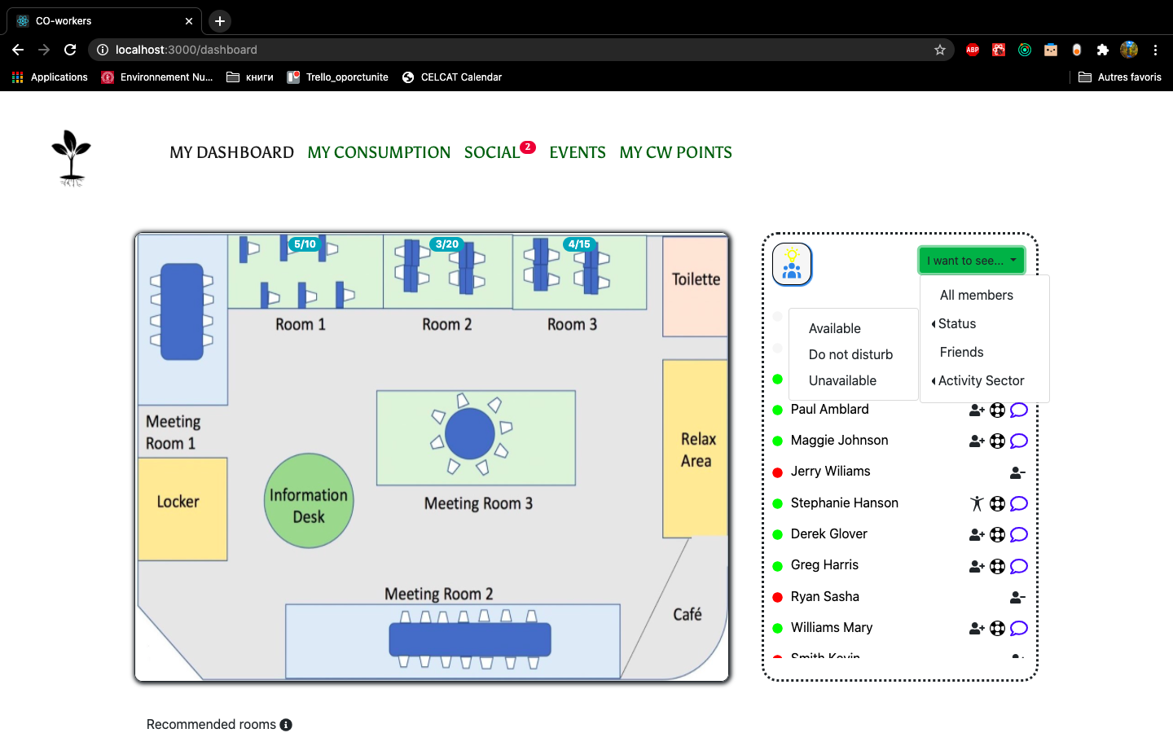

This map was an essential feature of our app and it provided data about each user in the co-working space: their activity, the room they are in, their mood, etc…

We also developed a very complete filtering system for viewing only specific types of users. A user could for instance see only the available lawyers or computer scientists in their friend list !

To encourage interactions between co-workers we also had a ‘help request’ button that would immediately send a notif to all concerned users.

Users also have recommendations based on their profile and the rooms busyness

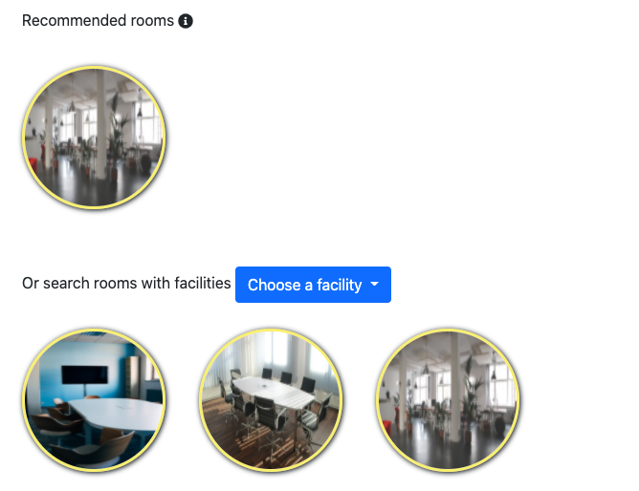

All of these features were of course only possible with a solid back end api that we tested with Postman.

Additionaly to this Node api, we also had a face recognition web service in Flask (Python) and on-board code for raspberry pis.

The Node Api was the central node between our IoT devices, the face reco web service and the web app;

**Three.js portfolio RPG style game**

In december 2020, as I decided to make a portfolio project for several reasons:

-it’s impossible to fit in the CV

-As a web developer, I felt like I should probably do a website for fun to present all my work done as a student.

-You can do whatever you want, really

-I had a lot of free time (dashed)

I always had this child dream to be able to create an open virutal world in which I could create my own rules and code whatever I wanted. Also, as I love Javascript I decided to give a try to Three.js, a js 3d library. As I was a complete newbie to 3d, it was a sort of half-step out of my comfort zone. I didn’t regret it since it was likely the most exicting project I ever had.

The art and come from OpenGameArte.org, Mixamo, SketchFab.

I used Blender to tune a little the model that I found on the internet and make them exploitable in Three.js, reduce the size of the textures, polygones to accelerate the loading process and optimize FPS.

I started by defining the movement and animations of the character.

This project was extremely challenging as I had a very short amount of time to learn Three.js, get in touch with 3d, Blender, animations…

But I learnt so much from it and understood the very basics of how 3d games are made.

Beware that this app is not made for mobile, as it hasn’t really been tested on it and performance issues might appear.